USCLC Registry Getting Started Guide

Prepared by
Jeff Schwartz, Founder of Answers Ahead
Elise A. Olsen, MD, USCLC Registry Chairman

July 12, 23
Version: 1.7

Welcome!

Welcome to the USCLC Registry! These instructions should help your site get started on data entry. There are multiple steps but all are fairly easy to complete. And both the Central Site (Duke) and Answers Ahead (Jeff Schwartz) are here to answer any questions you may have.
The first thing your site will need to do is to inform Duke at either USCLC-Duke@Duke.edu or the Registry Chairman, Dr. Elise Olsen at Elise.olsen@duke.edu that your site is interested in becoming a Registry member. You will be directed to the documents you will need to have completed prior to being given access to the Registry for data entry and a Duke Box set up for you to upload critical information on your site. These include your site’s IRB approval of the Registry protocol and informed consent form (ICF) and your site’s USCLC Site Agreement and Answers Ahead End User License Agreement (EULA) signed by your institution’s legal team. Once all critical documents have been uploaded, Duke will notify Answers Ahead and will let .
Answers Ahead will then reach out to the PI who will be sent an email with the subject line Answers Ahead Account Activation - USCLC. The email provides important information on access, most notably his or her temporary password and a link to activate his or her institution’s account.
Your PI will then inform Answers Ahead of who he or she would like to have access to the Registry to enter data. That information should also be uploaded into the site’s Duke box. Those individuals will then be sent an email with the subject line Answers Ahead Account Activation - USCLC. The email provides important information on access, most notably their temporary password and a link to activate their account. Please note this is the time to make sure your membership dues for USCLC have been paid for this year as data entry in the Registry is linked to active membership. Christine Lenihan, USCLC administrator, will be in communication with Answers Ahead on your membership status and this information will be recorded on the Registry site.
If there is another physician at your site who is IRB approved as a Co-Investigator for the study and wishes to enter data on his or her patients separately vs under the PI, please contact the Dr. Olsen at elise.olsen@duke.edu. That Co-Investigator must be a member in good standing of the USCLC as well as the PI.

Activating Your Account
- Open a web browser and navigate to the link in the email (see number 2)
- https://www.answersahead.io/auth/verify?tenant=usclc
- Since your site has already signed the End User License Agreement (EULA), please scroll to the bottom of the EULA and click the checkbox next to the statement I agree to the Terms and Conditions
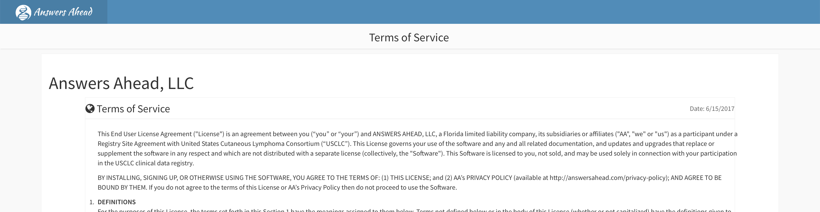

- Click the button I Agree
- This will take you to a page titled Setup Account Password
- Enter you email address
- Enter the temporary password
- Enter your new password
- Re-enter your new password (see image on next page)
- Click the Next button
- There should be a message that says Password updated
- You may now login:
  - The registry is always usclc — all lowercase
  - Enter your email address — all lowercase
  - Enter your new password
- Once logged in you will see the Subject List (see below)
- At the bottom of the Subject List you can find your:
  - USCLC Membership Renewal Date. If your site PI has not paid current dues, he or she will need to do so to continue forward. Please contact Christine Lenihan at Christine.lenihan@tnmed.org to pay dues. Once paid, she will inform Answers Ahead.
  - IRB approval date is on the lower right. This is added by the USCLC Central Site with information you have provided and is stored in the USCLC Box. If this is not checked, you will not be able to enter patient data.

Consenting Subjects
You may consent the patient in person or online. Please note that the following are needed for a fully executed ICF:
- Use of proper, current consent version. Any renewal of IRB approval of the protocol will likely update the version of the consent form to use. Please check that your consent form is the most updated and approved version;
- All expected signatures, dates, and, if pertinent at your site, times are filled out fully at the end of the consent;
- Subject initials should be signed in the lower right corner of all pages except for final page;
- Please double check that all components of the consent form have been signed and dated appropriately before the patient leaves the clinic. If there are omissions or errors, the patient will have to sign a new consent form at the next visit, and further data cannot be entered in the Registry until that is completed.

Generating a Unique Study Number
When you have completed consenting a patient, you should log in to Answers Ahead
- Opening a web browser and navigate to the login page at: https://www.answersahead.io/auth/login?tenant=usclc
- Enter usclc for the registry, followed by your email (all lowercase) for the username. Enter the password you created followed by the Login button.
- A successful login will bring you to the Subject List (see below) which includes all of patients associated with your site.
- Click the New button
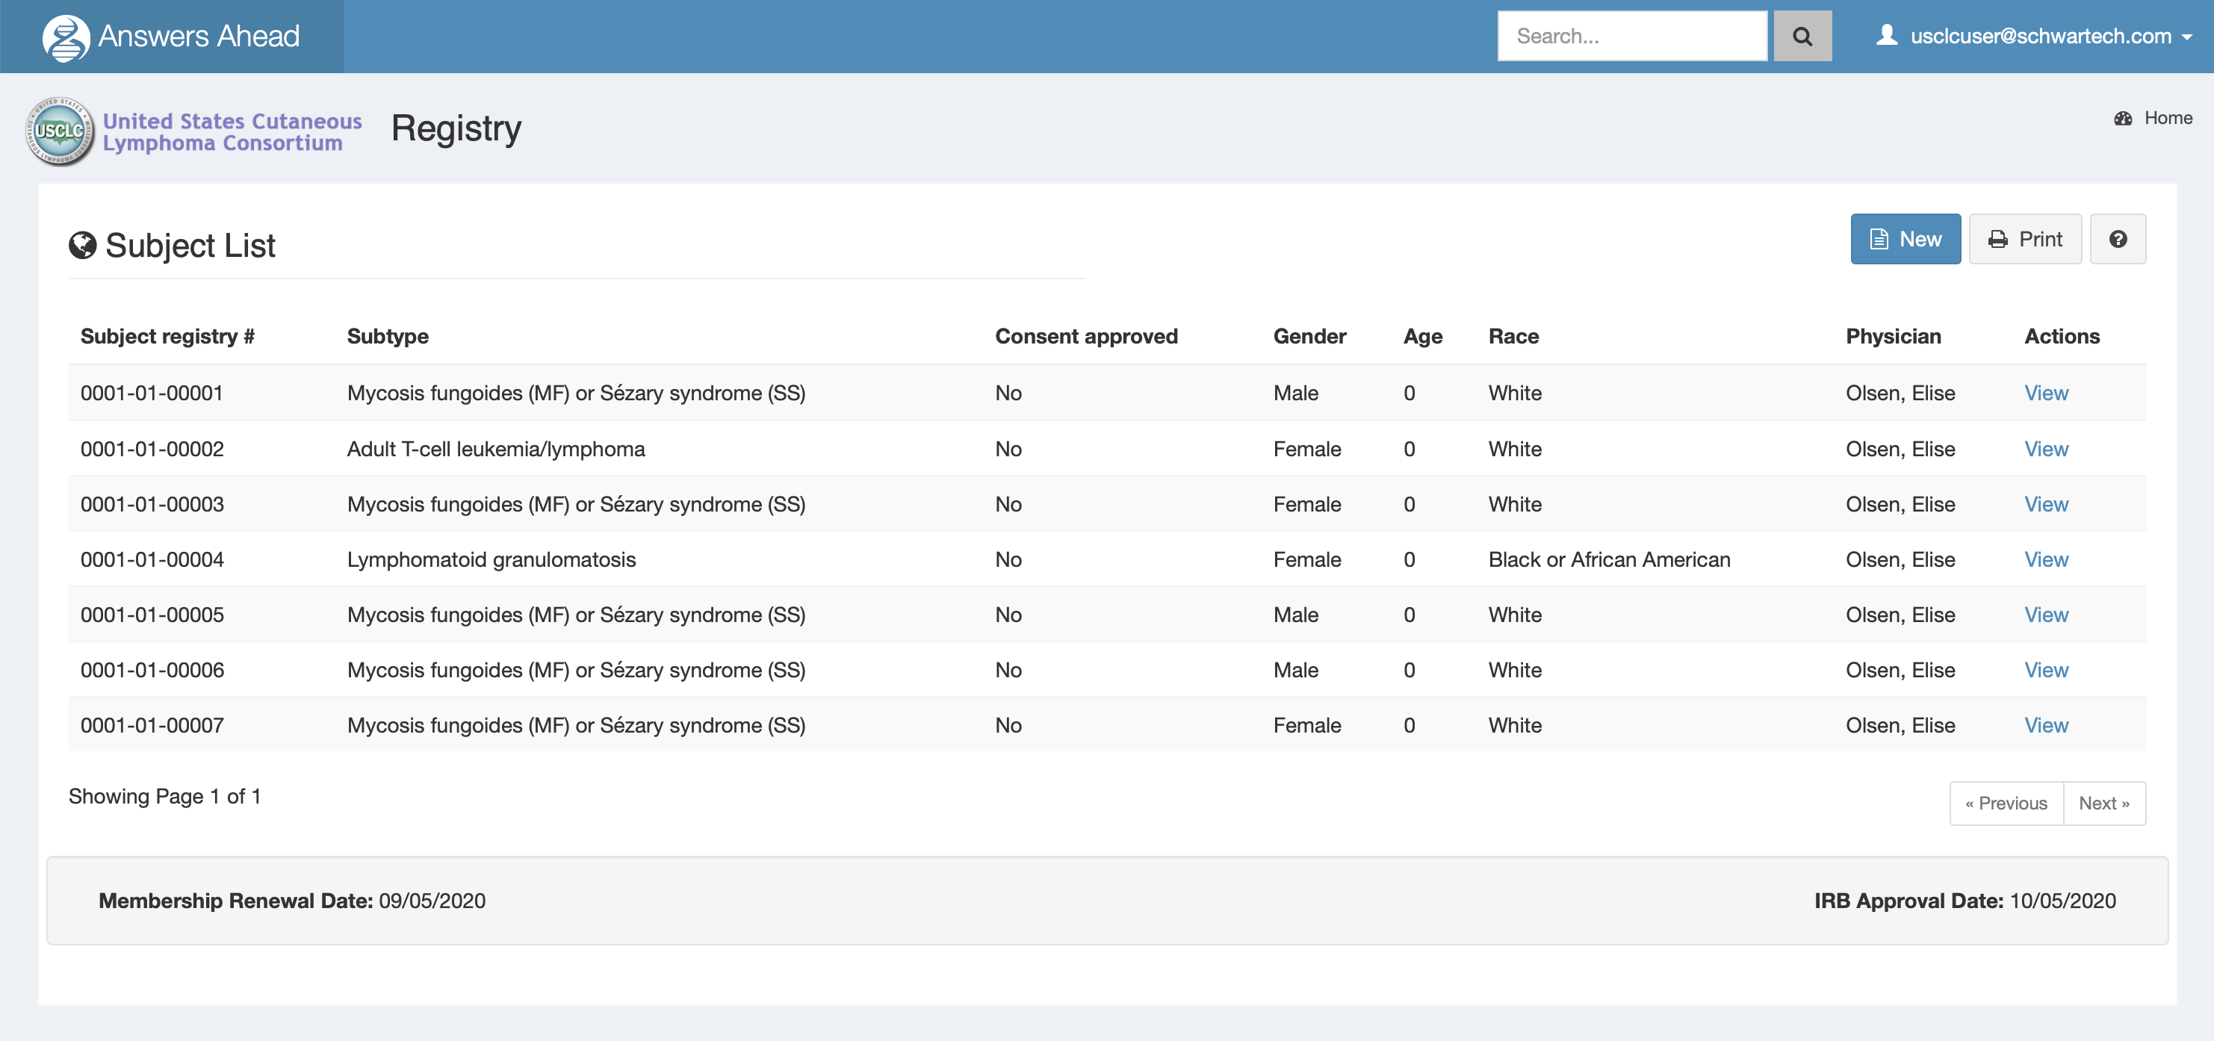

- You will be brought to the Consent Data page
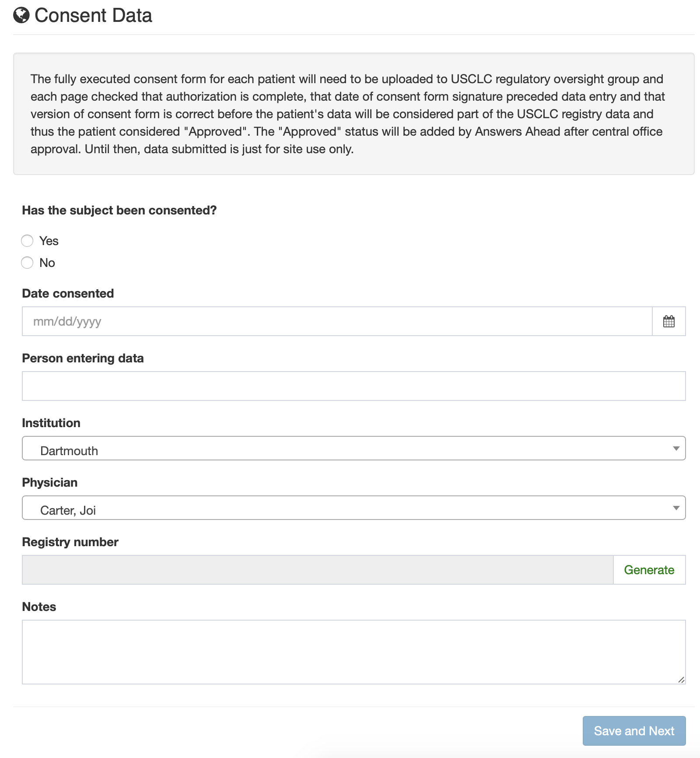

- Click the Yes to indicate that the subject has been consented
- Enter the date the subject was consented
- Enter the name of the person entering the data
- Your institution and physician should already be selected
- Press the Generate button to create the USCLC Registry number
- Click the Save and Next button.
- At this point, you can elect to log out and enter data later or continue to add data. Regardless of whether you continue to add data at this point, you will need to do the following with the subject’s ICF.

Finalization of Consent Form Documentation
- Please add the unique USCLC Registry Study Number to the upper right corner of the patient’s fully executed ICF.
- Scan and save the ICF (with the Study Number added) with the electronic title of “Consent-Unique Number- Date”
Example: Consent- 0001-01-00003- 30Aug22.pdf
- Upload the ICF (with Unique Study Number added) to the secure USCLC Registry Box folder that each site has been individually assigned.
- Once the ICF has been received in the USCLC Registry Box, it will be reviewed within 10 business days to ensure correct consent version and for completeness.
  - If there are no issues, a key will be made of subject name and DOB, site, physician, date of consent, and USCLC Registry number. The consent form will then be destroyed and Answers Ahead and site will be informed that local data is now able to be moved to aggregate USCLC data and further data may be entered on this patient. The site should keep a fully executed version of the ICF with the study number at their site.
  - If there are problems with the consent form, the USCLC Central Site will notify the site via email within 10 days of issues with the ICF, your site will be asked to correct the issue(s), and resubmit the ICF to the USCLC Registry Box. The site has 4 weeks in which to insure that there is a fully authorized and approved ICF for any individual patient whose data is to be entered into the Registry. Once the ICF has been approved as fully authorized, a key will be made of subject name and DOB, site, physician, date of consent, and USCLC Registry number. The consent form will then be destroyed and Answers Ahead and site will be informed that local data is now able to be moved to aggregate USCLC data and further data may be entered on this patient. The site should keep a fully executed version of the ICF with the study number at their site.

Support for Access to the Registry or navigating the Registry
Hours: 9am - 5pm EST, Monday - Friday
Email: support@answersahead.com

Contact Information
For questions related to Regulatory issues or ICF review and approval by USCLC Central Site, please contact usclc-duke@duke.edu

For general questions related to Answers Ahead, please contact Jeff Schwartz at jeff@answersahead.com or 773-771-5333.

For questions about your USCLC membership, please contact Christine Lenihan at
Christine.lenihan@tnmed.org
For general questions related to the protocol or if you are not receiving the necessary answers to your questions from the above contacts, please contact Dr. Elise Olsen at elise.olsen@duke.edu.

Quick information

Login
URL: https://www.answersahead.io/auth/login?tenant=usclc
Registry: usclc
Username: Email address (lowercase)
Password: The password created for the account

Forgot Password / Password Reset
Click I forgot my password from the Login URL above or click this link
https://www.answersahead.io/auth/forgetPassword
Registry: usclc
Username: Email address (lowercase)

